

**CANCER VISION: ADVANCED BREAST CANCER PREDICTION WITH DEEP LEARNING**

**A Project Report**

***Submitted by***

|  |  |
| --- | --- |
| **Abdul Khader N** | **2020504501** |
| **Akilesh S** | **2020540509** |
| **Amridha Lakshmi Venkkautaesh** | **2020504510** |
| **Sahana S** | **2020504572** |

***In partial fulfilment of the requirements of the course***

**Professional Readiness for Innovation,**

**Employment& Entrepreneurship**

**Under Naan Mudalvan Scheme**



**DEPARTMENT OF ELECTRONICS ENGINEERING**

**MADRAS INSTITUTE OF TECHNOLOGY**

**ANNA UNIVERSITY, CHENNAI-600044INTRODUCTION**

**1.1 Project Overview**

Cancer has become one of the major public health problems that seriously threaten the health of people. The incidence and mortality of breast cancer have been rising continuously in recent years. Early accurate diagnosis is the key to improve the survival rate of patients. A magnification-independent model has the ability to benefit directly from additional training data, and this additional data could be captured with the same or even different magnification factors. The objective of the project is to compare breast cancer detection with four model networks of deep learning techniques independent of the magnification factor of the histopathological images in the dataset and to conclude which model is more efficient in this specific approach. The overall procedure involves image preprocessing, classification and performance evaluation.

In our project, we have evaluated the performance of a deep learning model network named convolutional neural network (CNN) and it is used to classify between normal tumor and abnormal tumor using the Kaggle dataset.

**Purpose**

Developing a breast cancer detection model serves several important purposes in the field of healthcare. One of the primary objectives is to improve early detection and diagnosis of breast cancer, which is crucial for effective treatment and improved patient outcomes. Breast cancer is one of the most common types of cancer among women, and early detection can significantly increase the chances of successful treatment and survival.

By leveraging advanced technologies such as machine learning and artificial intelligence, the breast cancer detection model can analyze various types of data. The model is designed to identify patterns, anomalies, or potential indicators of breast cancer within the data, allowing for early intervention and appropriate medical care. The development of breast cancer detection models aims to enhance the accuracy of diagnosis. Traditional screening methods may sometimes produce false negatives or false positives, leading to missed diagnoses or unnecessary interventions. Detection models have the potential to minimize such errors by analyzing vast amounts of data with high precision, thereby improving the accuracy of breast cancer detection. This can help healthcare providers avoid unnecessary biopsies or ensure that suspicious findings are not overlooked.

Furthermore, the development of breast cancer detection models contributes to research and the generation of valuable insights. Analyzing large datasets collected through these models can provide researchers with a wealth of information about breast cancer epidemiology, risk factors, treatment responses, and other related areas. Such insights can drive further advancements in breast cancer detection and treatment, ultimately leading to improved outcomes for patients.

**IDEATION AND PROPOSED SOLUTION**

**2.1 Problem Statement Definition**

The diagnosis procedure of breast cancer is operator dependent and requires an experienced pathologist. However, some human factors like exhaustion and insufficient concentration could cause the misdetection of sample type within long and continuous procedures. In order to counteract the lack of experienced pathologists, the possibility of human error, the time-consuming process of screening samples, and the high cost, several Computer-Aided Diagnosis (CAD) techniques for early and automatic 3 detection of breast cancer have been proposed and evaluated by researchers in the past [8]. Machine learning approaches nowadays are frontier in the CAD trend. With the rise of deep learning, many studies have used this method in order to precisely detect sample types in histology images.

**2.2 Empathy Map Canvas**

An empathy map is a simple, easy-to-digest visual that captures knowledge about a user’s behaviours and attitudes. It is a useful tool to helps teams better understand their users.

Creating an effective solution requires understanding the true problem and the person who is experiencing it. The exercise of creating the map helps participants consider things from the user’s perspective along with his or her goals and challenges.

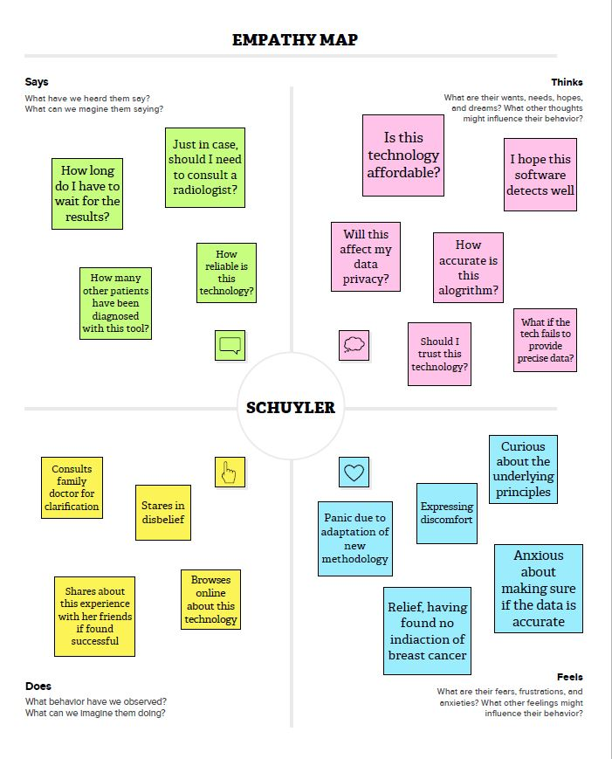

**2.3 Ideation & Brainstorming**

Brainstorming provides a free and open environment that encourages everyone within a team to participate in the creative thinking process that leads to problem solving. Prioritizing volume over value, out-of-the-box ideas are welcome and built upon, and all participants are encouraged to collaborate, helping each other develop a rich number of creative solutions.

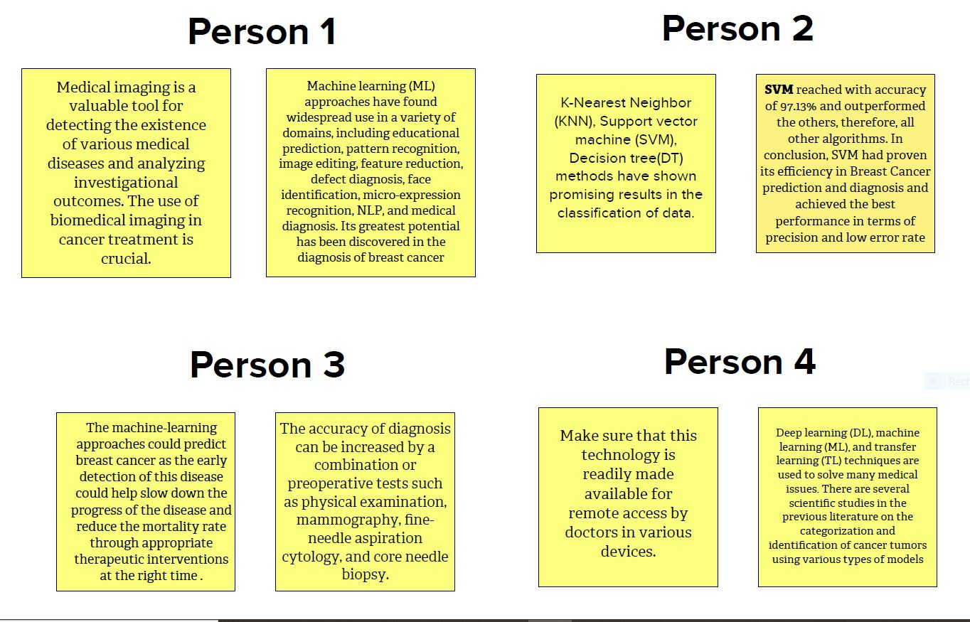

**Grouping:**

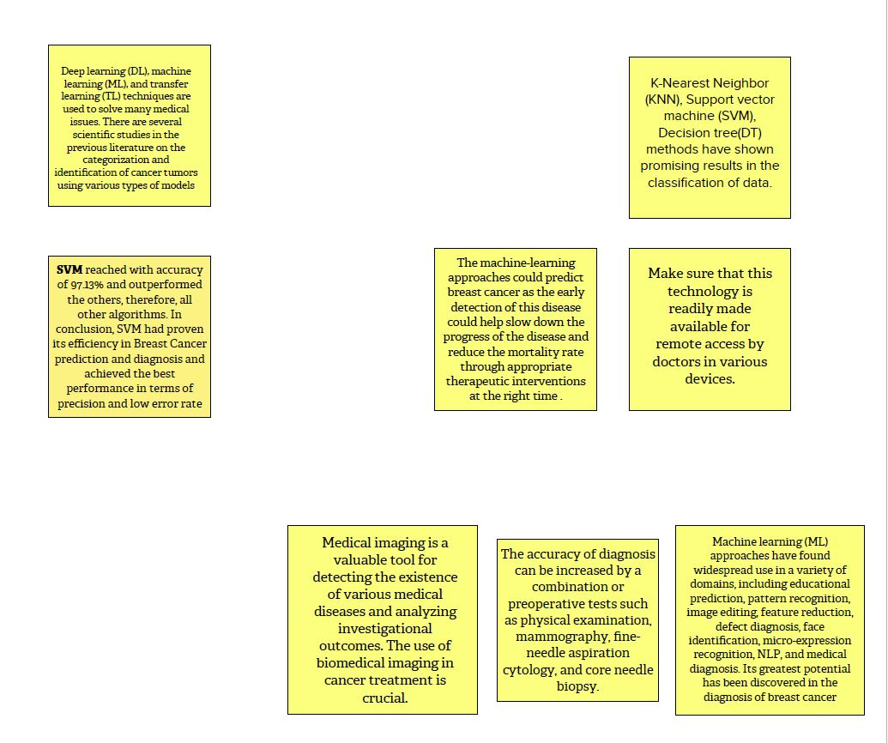

**Idea Prioritization**

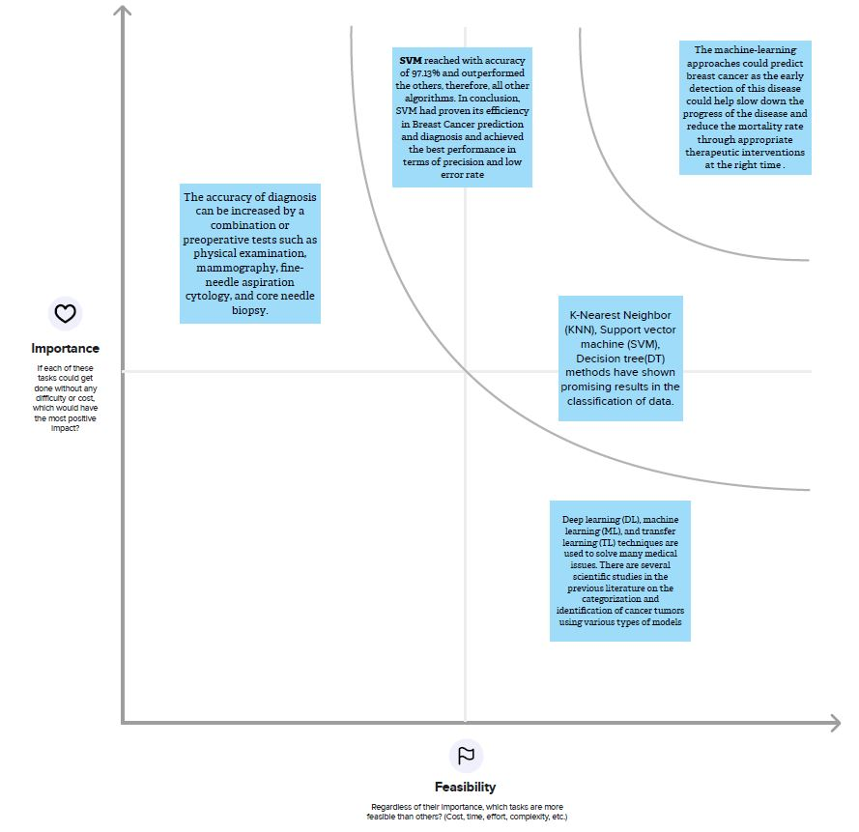

**2.4 Proposed Solution**

|  |  |  |
| --- | --- | --- |
| **Sl.No.** | **Parameter** | **Description** |
|  | Problem Statement (Problem to be solved) | To detect the breast cancer at early stages. |
|  | Idea / Solution description | AI and ML algorithms can analyze medical images and other patient data to identify patterns that may be indicative of breast cancer. |
|  | Novelty / Uniqueness | These techniques have better speed and efficiency, reduced costs, personalized medicine, early detection. |
|  | Social Impact / Customer Satisfaction | The social impact of AI-based breast cancer detection is significant. It has the potential to improve healthcare access, reduce healthcare costs, increase patient empowerment, reduce healthcare disparities, and make more efficient use of healthcare resources. |
|  | Business Model (Revenue Model) | Diagnostic service model: In this model, a company could offer AI-based breast cancer detection as a service to healthcare providers, charging a fee for each diagnostic report generated. |
|  | Scalability of the Solution | The scalability of AI-based breast cancer detection makes it a promising technology.  It has access to large scale data, Cloud-based solutions, Automation, Integration with existing systems, Transfer learning. Thus, improving the accuracy and efficiency of breast cancer detection on a large scale. |

**REQUIREMENT ANALYSIS**

**3.1 Functional Requirement**

The following are the functional requirements of the proposed solution.

|  |  |  |
| --- | --- | --- |
| **FR No.** | **Functional Requirement (Epic)** | **Sub Requirement (Story / Sub-Task)** |
| FR-1 | User Registration | Registration through Form.  Registration through Gmail. |
| FR-2 | User uploads the images in the page | The historiographic Images are fed in the webpage. |
| FR-3 | User Results | The Prediction is appeared in the webpage. |

**3.2 Non-Functional requirements**

The following are the non-functional requirements of the proposed solution.

|  |  |  |
| --- | --- | --- |
| **FR No.** | **Non-Functional Requirement** | **Description** |
| NFR-1 | **Usability** | The application interface of the model is highly user-friendly. By ensuring an intuitive and accessible user interface, customizability, integration with existing systems, and fast and accurate performance, healthcare providers can maximize the benefits of the AI model and improve patient outcomes. |
| NFR-2 | **Security** | The security of a breast cancer detection AI model can be ensured through a combination of data privacy, model security, regular updates, and regular security assessments. The data to be fed in the model is uploaded and processed in a secure manner. |
| NFR-3 | **Reliability** | By ensuring high-quality training data, robust algorithms, thorough validation and testing, seamless integration with clinical workflows, and ongoing monitoring and refinement, healthcare providers can ensure that the model is reliable and produces accurate and consistent results. |
| NFR-4 | **Performance** | The AI model is efficient and provides accurate results detecting the type of the tumor. |
| NFR-5 | **Availability** | The model is reachable and attainable to everyone irrespective of their location. |
| NFR-6 | **Scalability** | The webpage is scalable to support high network traffic. The AI model can handle increasing volumes of data and workloads while maintaining accuracy and performance. |

**PROJECT DESIGN**

**4.1 Data Flow Diagrams**

A Data Flow Diagram (DFD) is a traditional visual representation of the information flows within a system. A neat and clear DFD can depict the right amount of the system requirement graphically. It shows how data enters and leaves the system, what changes the information, and where data is stored. User or Patient.

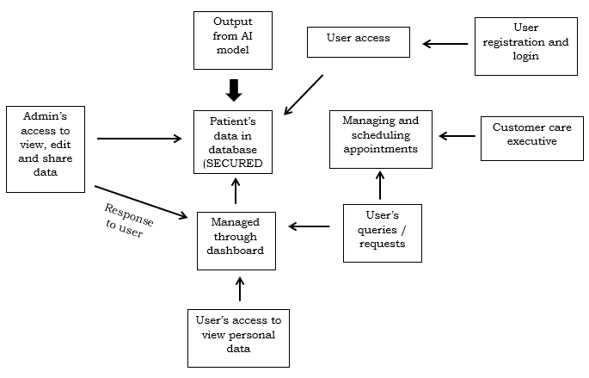

**4.2 Solution & Technical Architecture**

Solution architecture is a complex process – with many sub-processes – that bridges the gap between business problems and technology solutions. Its goals are to:

* Find the best tech solution to solve existing business problems.
* Describe the structure, characteristics, behavior, and other aspects of the software to project stakeholders.
* Define features, development phases, and solution requirements.
* Provide specifications according to which the solution is defined, managed, and delivered.

**4.2 Solution & Technical Architecture:**

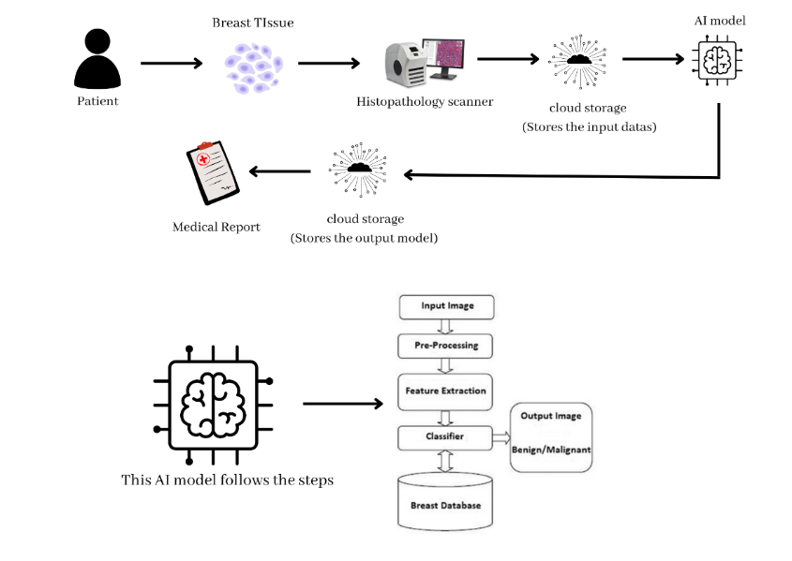

**4.3 User Stories**

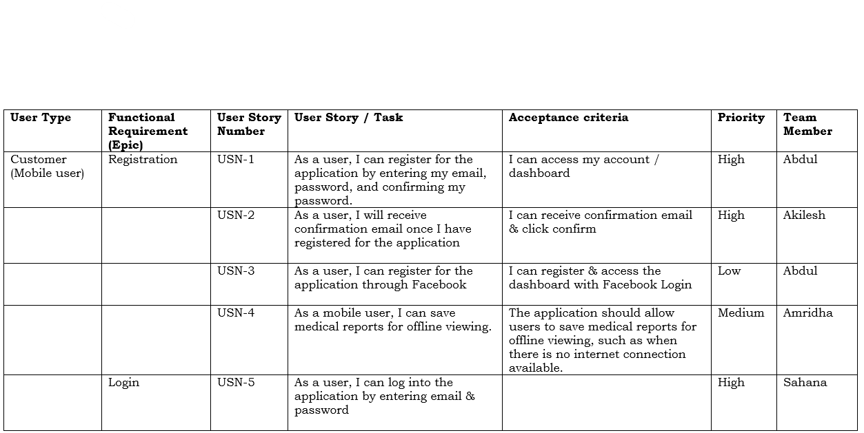

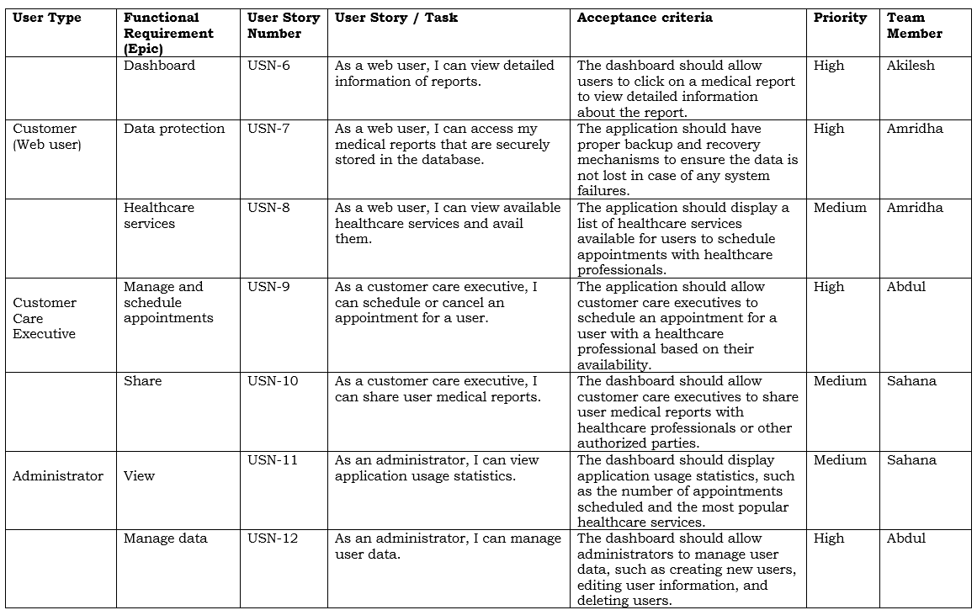

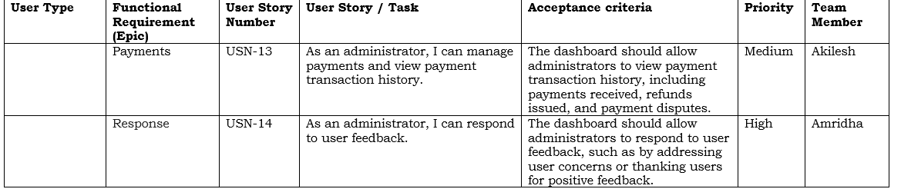

**CODING AND SOLUTIONING**

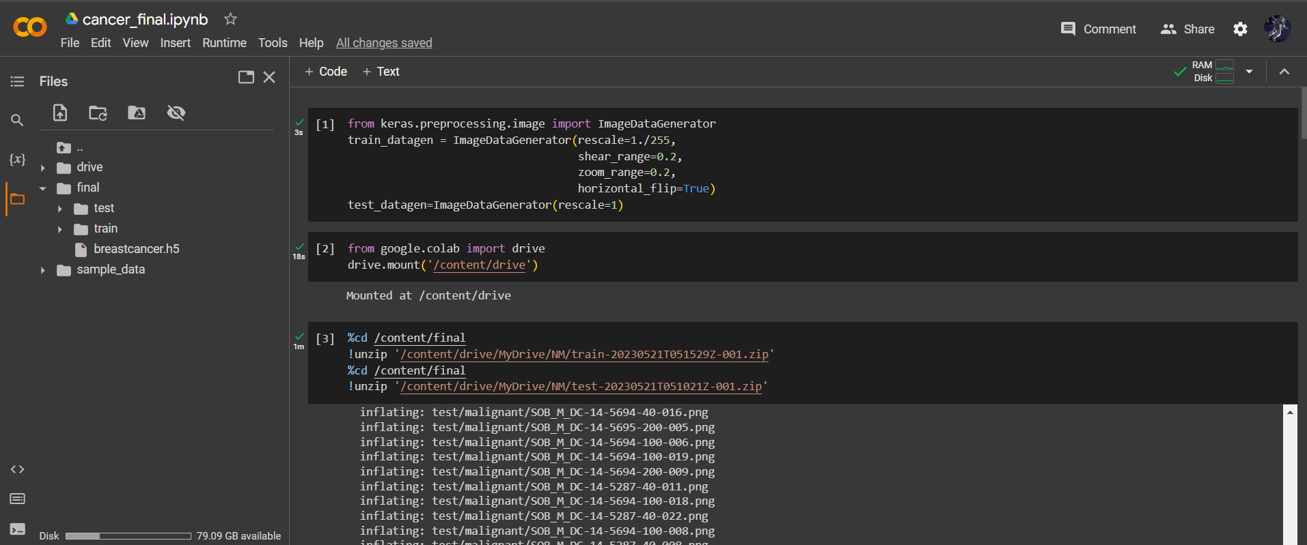

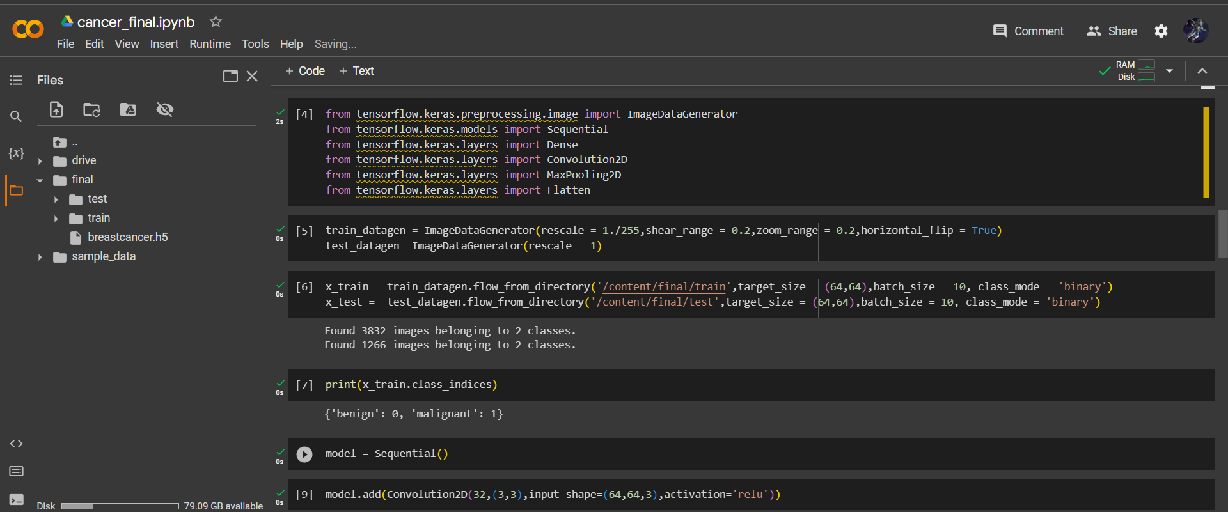

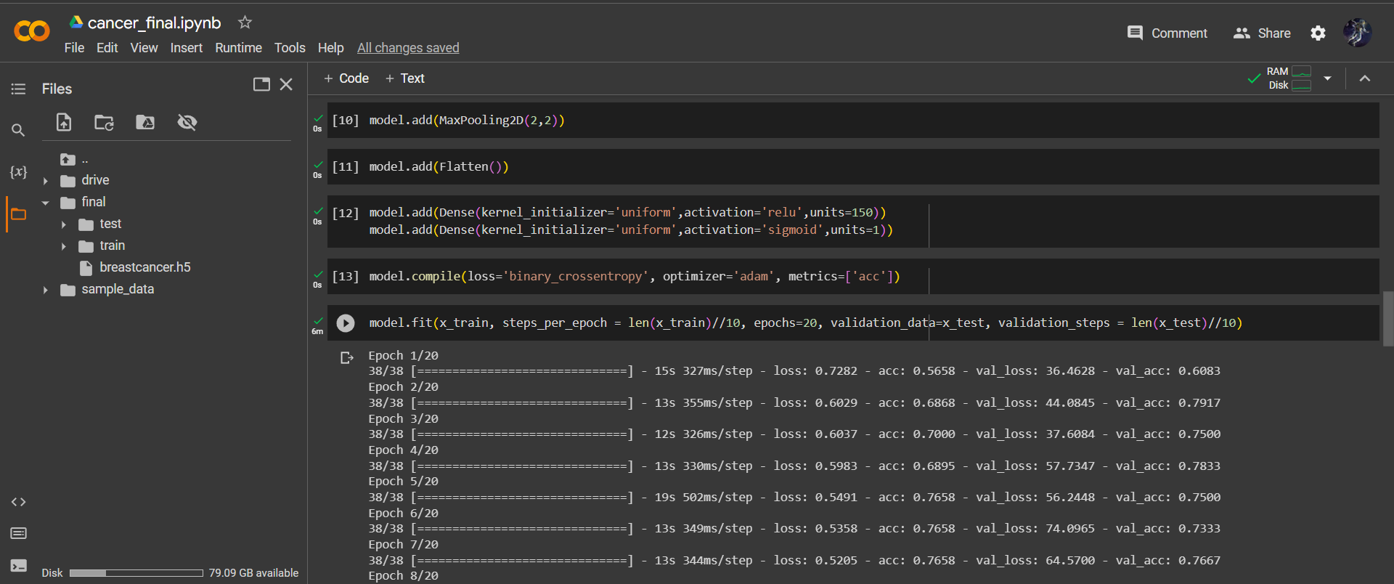

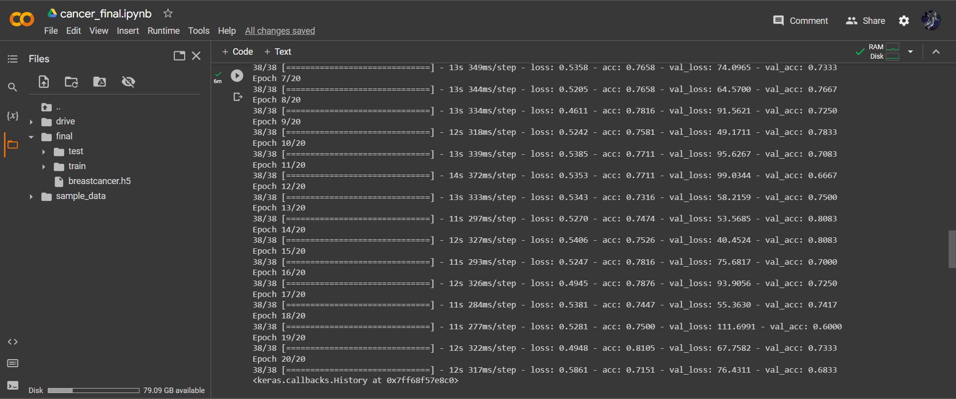

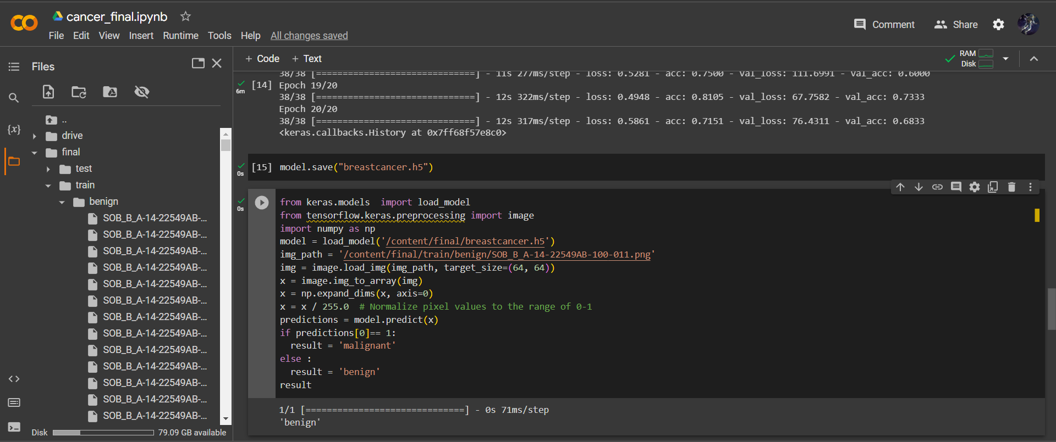

**RESULT**

**Training summary:**

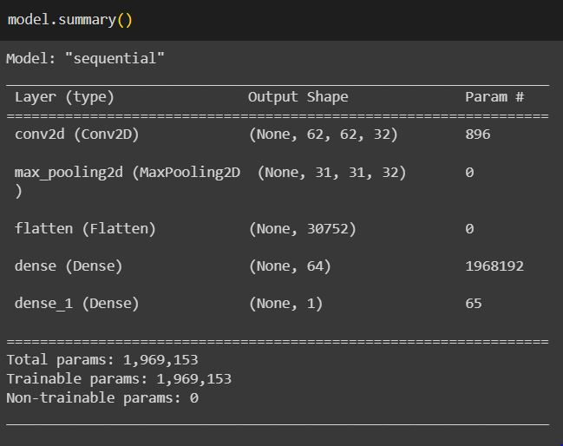

Training Accuracy – 0.8105  
  
Validation Accuracy – 0.8083

This study showcased the potential of deep learning methods, particularly CNN architectures, in breast cancer detection using histopathological images. The results highlight the importance of model selection and architectural design in achieving high accuracy and performance. These findings suggest that deep learning-based approaches hold promise for enhancing breast cancer detection and assisting pathologists in making accurate diagnoses. Further research and validation on larger and more diverse datasets are warranted to consolidate the findings and facilitate the clinical translation of these methods.

GITHUB LINK :

<https://github.com/naanmudhalvan-SI/PBL-NT-GP--7446-1681098572>

DEMO VIDEO LINK :

<https://clipchamp.com/watch/PVZCmKLrZ0I>

**ADVANTAGES & DISADVANTAGES**

Advanced breast cancer prediction using deep learning techniques offers several advantages, including:

***1. Increased accuracy:*** Deep learning algorithms can analyze large volumes of complex data, including medical imaging and patient records, to identify subtle patterns and features that may not be easily detectable by human observers. This can lead to improved accuracy in breast cancer prediction compared to traditional methods.

***2. Early detection:*** Deep learning models can be trained to detect early signs of breast cancer, even before symptoms are clinically apparent or visible on traditional imaging. By identifying subtle patterns in medical images or patient data, deep learning algorithms can aid in the early detection of breast cancer, potentially allowing for earlier intervention and improved treatment outcomes.

***3. Efficiency and automation:*** Deep learning models can process and analyze large amounts of data quickly and efficiently, reducing the time required for diagnosis and prediction. This can improve workflow efficiency for healthcare professionals and potentially reduce delays in initiating appropriate treatment.

***4. Personalized risk assessment:*** Deep learning algorithms can incorporate various risk factors, including genetic, clinical, and imaging data, to provide personalized risk assessments for individual patients. This can help stratify patients into different risk categories, enabling targeted screening strategies and personalized preventive measures.

***5. Reduction in false positives and false negatives:*** Deep learning models have the potential to reduce false positives (incorrectly classifying a non-cancer case as cancer) and false negatives (missing cancer cases). By leveraging large datasets and complex algorithms, deep learning can enhance the sensitivity and specificity of breast cancer prediction, improving overall accuracy.

***6. Integration with existing healthcare systems:*** Deep learning models can be integrated with existing healthcare systems and imaging modalities, allowing for seamless incorporation into clinical practice. This facilitates the adoption and implementation of advanced breast cancer prediction methods into routine care, making it more accessible to patients.

***7. Continual improvement:*** Deep learning models can continuously learn and improve their performance over time. As more data becomes available and the models are exposed to diverse cases, they can refine their predictions and become increasingly accurate in breast cancer prediction.

It's important to note that while deep learning shows promise in breast cancer prediction, it should be used as a supportive tool for healthcare professionals rather than a replacement for clinical expertise. The models should undergo rigorous validation and be carefully integrated into clinical workflows to ensure their safety and efficacy.

While advanced breast cancer prediction using deep learning offers several advantages, it is also important to consider potential disadvantages and limitations. Here are some of the drawbacks associated with this method:

***1. Data availability and quality:*** Deep learning models heavily rely on large and high-quality datasets for training. However, obtaining comprehensive and diverse datasets, particularly with well-annotated and accurately labeled breast cancer cases, can be challenging. Biases in the data, such as imbalanced representation of certain demographics or imaging techniques, may impact the performance and generalizability of the model.

***2. Interpretability and transparency:*** Deep learning models often operate as "black boxes," meaning they make predictions based on complex algorithms that can be difficult to interpret or explain. This lack of interpretability can be a concern in the medical field, where transparency and ease of explaining are crucial for gaining trust from healthcare professionals and patients. Understanding the reasoning behind the model's predictions is important for clinical decision-making and acceptance.

***3. Overfitting and generalizability:*** Deep learning models can be prone to overfitting, wherein they become overly specialized to the training data and fail to generalize well to new, unseen data. This can limit their effectiveness in real-world clinical settings where variations in patient populations, imaging techniques, and disease presentations are encountered. Robust validation and testing on diverse datasets are necessary to ensure the model's generalizability and performance in different scenarios.

***4. Ethical considerations***: The use of deep learning algorithms in healthcare raises ethical concerns, such as data privacy, security, and potential biases in the algorithms themselves. Ensuring patient privacy and maintaining the security of sensitive medical data is crucial when implementing these technologies. Additionally, biases can inadvertently be present in the algorithms if the training data is biased or if biases are not addressed during the model development process.

***5. Regulatory and legal challenges:*** Implementing deep learning models in clinical practice involves navigating regulatory requirements and legal considerations. Ensuring compliance with regulations, obtaining necessary approvals, and addressing liability issues can pose challenges and require extensive resources.

***6. Integration and workflow challenges:*** Integrating deep learning models into existing healthcare systems and workflows can be complex. Technical considerations, such as compatibility with different systems and seamless integration with electronic health records (EHR), may need to be addressed. Additionally, changes to clinical workflows and the need for healthcare professionals to adapt to new technologies can pose practical challenges.

***7. Limited clinical impact evidence:*** While promising, the clinical impact and benefit of deep learning in breast cancer prediction may still need to be further validated and supported by robust clinical studies. Demonstrating improved patient outcomes, such as reduced mortality rates or increased survival rates, requires rigorous evaluation in real-world settings.

It's important to address these limitations and work towards developing transparent, interpretable, and clinically validated deep learning models to maximize the benefits and mitigate potential risks in breast cancer prediction. Collaboration between researchers, clinicians, and regulatory bodies is essential for responsible and effective implementation of these technologies.

**CONCLUSION & FUTURE SCOPE**

In conclusion, the development of an advanced breast cancer detection model using deep learning techniques has demonstrated promising results in improving the accuracy and efficiency of breast cancer diagnosis. The utilization of deep learning algorithms and the analysis of large-scale datasets have allowed for the identification of subtle patterns and features that might be overlooked by human observers. This model has the potential to revolutionize breast cancer detection by assisting healthcare professionals in making more accurate and timely diagnoses, ultimately leading to better patient outcomes.

The future scope of this project is vast and holds tremendous potential for further advancements. Firstly, the model can be refined and optimized to enhance its performance by incorporating additional layers, utilizing more diverse datasets, and fine-tuning hyperparameters. Additionally, efforts can be made to expand the application of deep learning techniques to other forms of cancer detection, enabling early diagnosis and intervention. Furthermore, collaborations with healthcare institutions and researchers can facilitate the collection of more extensive and diverse datasets, enabling the model to become even more robust and reliable. The continuous improvement and validation of the model through rigorous clinical trials and real-world implementations will be essential to establish its effectiveness in a broader range of clinical settings.

In conclusion, the advanced breast cancer detection model using deep learning has laid the foundation for a new era in cancer diagnosis and holds immense potential for improving patient outcomes. With ongoing research and development, the integration of this model into clinical practice has the potential to revolutionize breast cancer detection and contribute to the larger field of medical imaging and artificial intelligence in healthcare.